**DBMS Laboratory**

**UE19CS304**

**5th Semester, Academic Year 2021-22**

Week #: 9 - Functions and Triggers Date: 26/11/2021

|  |  |  |
| --- | --- | --- |
| Name :  SUMUKH RAJU BHAT | SRN :  PES1UG19CS519 | Section :  H |

1. Create an employee table which contains employee details and the department he works for. Create another table department consisting of dname and number of employees. Write triggers to increment or decrement the number of employees in a department table when the record in the employee table is inserted or deleted respectively.

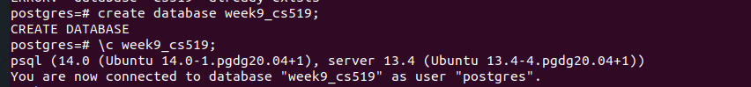

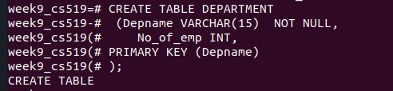

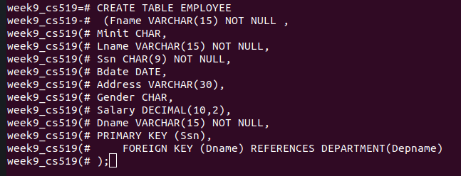

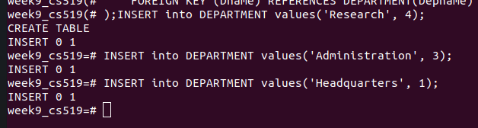

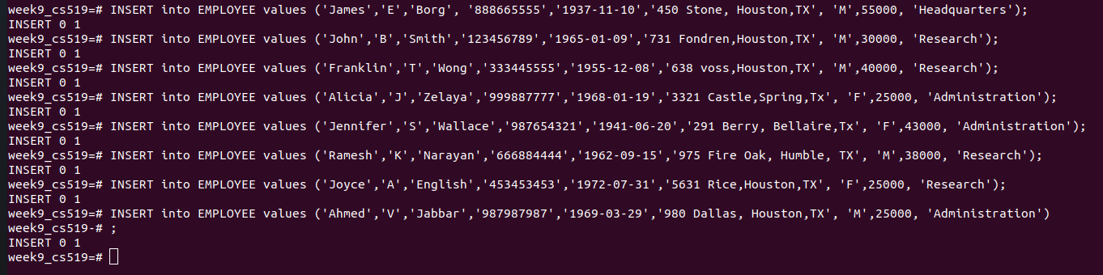

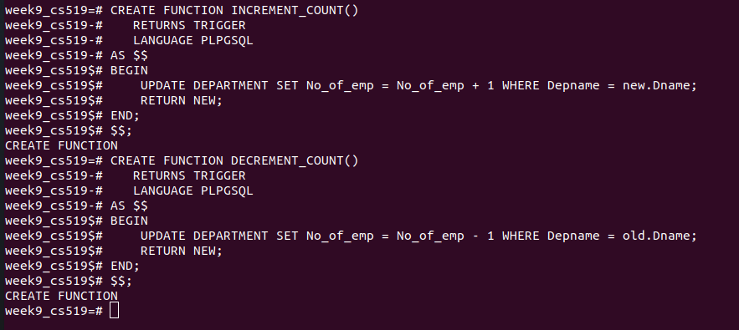

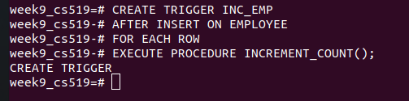

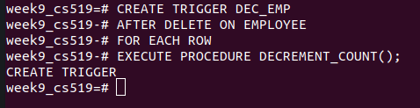

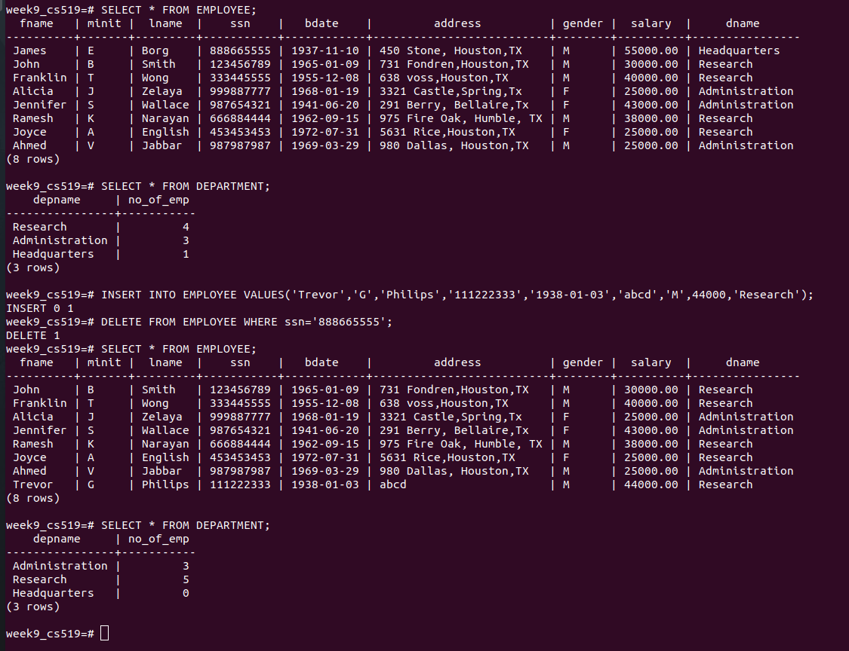

1. Create an order_item table which contains details like name, quantity and unit price of every item purchased. Create an order summary table that contains number of items and total price. Create triggers to update entry in order summary whenever an item is inserted or deleted in the order item table.

